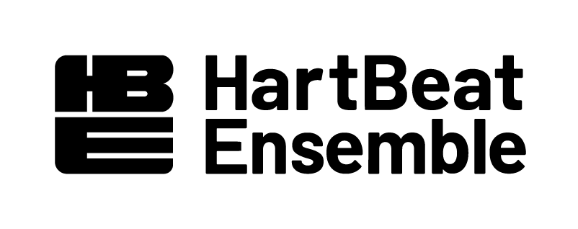
HARTBEAT ENSEMBLE’S YOUTH PLAY INSTITUTE -- FREQUENTLY ASKED QUESTIONS – Summer 2022

WHAT IS YPI?
HartBeat Ensemble’s Youth Play Institute (YPI) is a 5-week paid internship in dramatic writing, acting, light, stage, sound, and costume design or stage management for young adults between the ages of 16 and 21 years old. In this YPI session, a group of 10 young people will create and perform their own one-act play.

HOW DOES THE PROCESS WORK?
The group will conduct research and interviews on the topic of Youth Sanctuaries. Based on their findings, the group works together to write their scenes with guidance from HartBeat teaching artists. The program culminates with a public show of the group’s work, which is followed by a talkback with the audience about the play’s content.

WHEN AND HOW OFTEN DOES YPI MEET?
- There is a mandatory YPI orientation on Saturday, July 2nd, 10am - 1pm.
- The session begins July 4th and meets Monday - Thursday. from 10a-2p for 4 weeks.
- The Stage Manager is expected to work for an additional half hour each day, starting at 9:30a
- 5th Week: Tech Week, Mandatory for all Participants, Sunday, July 31st - Friday, August 5th 10a - 2p
- The shows in the theater are on Sat., August 6th at 7:30p & Sun., August 7th at 2p, with a mandatory clean -up/wrap-up session on Mon., August 8th 10a - 2p

WHERE DOES YPI MEET?
All sessions will be at the Carriage House Theater, 360 Farmington Ave., Hartford, CT 06105. At this time, masks are required for all in-door sessions. Participants must be vaccinated to attend the program and show proof of vaccination to enter the building.

WOULD I HAVE TO BE AT EVERY WORKSHOP/REHEARSAL?
Yes! Two pre-arranged, non-paid absences are allowed if need be. They cannot be during the final week. This information must be communicated ahead of time with Facilitators and the Stage Manager.

HOW MUCH WOULD I GET PAID?
Each intern is paid a stipend of $1000 for the whole program. Paychecks are docked for absences and lateness so be on time every time!

DO I HAVE TO BE ENROLLED IN A SCHOOL?
No. Anyone between the ages of 16 and 21 is eligible to interview for YPI.

WHAT KIND OF TRAINING WOULD I RECEIVE?
All interns have a part in creating the final show. Each intern is involved in writing dramatic material, performance, poetry, interviewing and research. Some will gain tech training in running light or sound cues.

WHEN ARE THE INTERVIEWS?
Mon., June 13th, 20th and Wednesday June 15th, 22nd from 6pm-8pm.
With other times available upon request.

HOW DO I SIGN UP FOR AN INTERVIEW?
Please email ypi@hartbeatensemble.org or use this link: https://forms.gle/XoeyAroZtEqddkpw7

WHAT DO I NEED TO PREPARE FOR THE INTERVIEW?
- A resume, if you have one.
- Be ready to discuss interest in the creative Arts.
- ALL applicants (including stage managers) will participate in ensemble activities and improvisations as part of the interview and even during the program.
- Please be in clothing you feel comfortable moving in.

WHAT HAPPENS AFTER THIS SESSION ENDS?

HartBeat Ensemble is looking to expand the reach of the work created by interns in YPI programming so it can be seen by more audiences statewide. We want participants to have the extended opportunity to not only share their work on stage again but get paid for creating theater with new audiences.

This summer 2022, the script created will be featured in the Hartford Fringe Festival for two shows! Interns participating in the summer intensive are invited to return to the stage in October 2022 and will receive additional payment for rehearsal, performances, and portion of the ticket sales from each show. More information is coming soon.

CAN PARTICIPATE AGAIN?
yes. :)

